CREATIVE EDUCATIONAL SERVICES
BEGINNING OF TERM I EXAMINATIONS 2024
MATHEMATICS
PRIMARY THREE

Name:……………………………………Class: ……….………
School: ………………………………………..………………….
SECTION A (1 mark each)
1. Multiply: 3 x 4 = _________

2. Write 175 in words.

3. Arrange the numbers from the biggest to smallest:
105, 50, 501, 150, 510: _______________________

4. Draw a curved line in the space given below.

5. What is 2 hundreds, 5 tens and 6 ones?

6. Add: 14 + 12 + 11 = __________

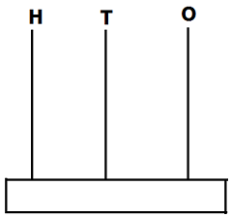7. Show 304 on the abacus below.

8. Name the shortest tree.

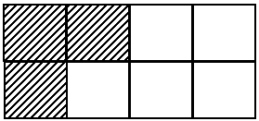9. What is the shaded fraction?

10. What time is shown on the clock face below?

11. One book costs sh. 200. How much money did Mary pay for 2 books?

12. Write 316 in expanded form.

13. Draw a set of 8 trees in the space given below.

14. Which number comes before 200?

15. Subtract: 33 – 13 = ___________

16. Today is Monday. What day of the week will it be after 3 days?

17. Divide: 12 ÷ 3 = _____________

18. Find the place value of 7 in 657.

19. Use a number line to find the answer: 5 + 3 = _____
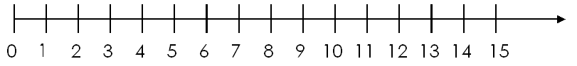

20. Write the missing number: 77, 76, 75, _____, 73, 72.
SECTION B (2 marks each)
21. Fill in the missing numbers.
(a) _____ + _____ = 12 (b) – 7 = 0
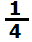(c) 4 x = 12 (d) ÷ 4 = 2
22(a)Shade of the figure below.

(b) Add: ²/₅ + ¹/₅ =

(c) Subtract: ⁷/₈ – ²/₈ =

(d) Sarah cut an apple into 6 equal pieces. She ate ⁵/₆ of the apple. How pieces did Sarah eat?

23. Subtract (Take away):
(a) Write the mathematical statement shown below:

(b) 4 6 (c) 3 6 9
– 3 6 – 2 0 7

(d) A shopkeeper had 36 rubbers in his shop. He sold 24 rubbers to Mary. How many rubbers remained in the shop?
__________________________________________________
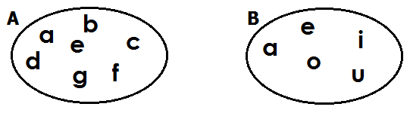24. Use the given sets to answer the following questions.

(a) Which set has more members?

(b) How many members are in:
(i) set B? (ii) set A?
(c) Write the members found in both set A and set B.

25. Add:
(a) 78 + 11 = ________
(b) 6 5 (c) 3 4 7
+ 1 0 + 6 5 2

(c) After selling 121 oranges, Ali had 232 oranges remaining in the bag. How many oranges were in the bag at first?

___________________________________________________
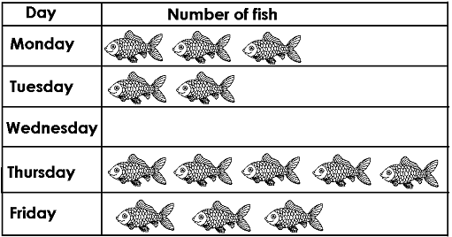26. The graph shows the number of fish Mary sold from Monday to Friday.

(a) On which day didn’t Mary sell any fish?
____________________________________________________
(b) On which days did Mary sell the same number of fish?
____________________________________________________
(c) How many fish did Mary sell on Thursday?
___________________________________________________
(d) Find the total number of fish Mary sold in the five days.

